Design and Performance Evaluation of SRP-6a as a Replay-Resistant Authentication Scheme in Web Applications

Darren Mansyl - 18223001
Program Studi Sistem dan Teknologi Informasi
Sekolah Teknik Elektro dan Informatika
Institut Teknologi Bandung, Jalan Ganesha 10 Bandung
E-mail: author@gmail.com , author@std.stei.itb.ac.id

Abstract—Traditional web application authentication mechanisms often rely on transmitting passwords over the network, which can expose users to interception and replay attacks, even when protected by Transport Layer Security (TLS). To mitigate these risks, this paper proposes the implementation of the Secure Remote Password (SRP-6a) protocol as a secure and replay-resistant authentication solution. SRP-6a is an augmented Password-Authenticated Key Agreement (PAKE) protocol that allows a client and server to authenticate each other without exchanging the actual password or storing plaintext equivalents on the server. This study presents the design and implementation of an SRP-6a-based authentication workflow within a modern web application architecture. In addition, a performance evaluation is conducted to assess the computational overhead introduced by the modular exponentiation operations required by SRP-6a, compared with conventional hash-based authentication methods. Experimental results show that although SRP-6a requires more computational time during the authentication phase, the latency remains within acceptable thresholds for user experience. These findings demonstrate that SRP-6a provides a substantial improvement in security against network eavesdropping and server-side credential database compromises while maintaining reasonable performance.
Keywords—SRP-6a, Authentication, Replay Attack, Web Security, Cryptography, PAKE

Introduction
The rapid expansion of web-based services has made secure user authentication a critical requirement. Most web applications still implement the traditional client-server authentication model, where the client transmits a plaintext password (or a hashed equivalent) to the server. Although Transport Layer Security (TLS) helps protect credentials during transmission, this approach still presents several security concerns. If the communication channel is compromised or users unknowingly interact with a malicious endpoint, their credentials may be exposed. Furthermore, conventional authentication mechanisms can be vulnerable to replay attacks, in which an attacker captures and retransmits authentication data to gain unauthorized access.
To address these challenges, researchers have developed Password-Authenticated Key Agreement (PAKE) protocols, which enable secure authentication without revealing the user's password. The Secure Remote Password (SRP) protocol, specifically the SRP-6a revision, is one of the most widely adopted PAKE schemes. SRP-6a guarantees that the password is never transmitted through the network in any form. Instead, the client and server authenticate each other by proving that they share the same password and simultaneously generate a cryptographically secure session key.
This paper presents the design, implementation, and evaluation of an SRP-6a-based authentication system for modern web applications. The proposed approach is evaluated in terms of its ability to prevent replay attacks and the computational overhead. Through experimental analysis, the study evaluates whether enhanced security offered by SRP-6a can be achieved without significantly affecting authentication performance in real-world applications.

Theoretical Background

Password-Authenticated Key Agreement (PAKE)
Password-Authenticated Key Agreement (PAKE) is a class of cryptographic protocols that enable two parties to establish a secure and authenticated communication channel using only a shared low-entropy secret, typically a password, without relying on a Public Key Infrastructure (PKI) or a trusted third party [1]. Unlike conventional password-based authentication systems, in which a password or its hash is transmitted to a server for verification, PAKE protocols are designed so that the password itself never traverses the network and cannot be verified through offline attacks using intercepted messages.
PAKE protocols are generally divided into two categories: balanced PAKE and augmented PAKE. In balanced PAKE, both parties store the same password and participate symmetrically in the authentication process. In contrast, augmented PAKE allows the server to store only a verifier derived from the password rather than the password itself. As a result, even if the server database is compromised, an attacker cannot immediately recover user credentials or impersonate the client without performing a computationally expensive password-guessing attack.
The security of PAKE protocols has been extensively studied using formal cryptographic models. Among the most widely adopted are the Bellare–Pointcheval–Rogaway (BPR) model and the Universal Composability (UC) framework proposed by Canetti. These models consider adversaries capable of controlling network communications and initiating multiple concurrent sessions. Within these frameworks, a secure PAKE protocol is expected to provide mutual authentication, session key secrecy, and resistance to dictionary attacks. In particular, an attacker should gain at most one password guess per interaction with the server, preventing large-scale offline password-cracking attacks.
Several PAKE protocols have been proposed over the years, including SPEKE, the SRP family, CPace, and the more recent OPAQUE protocol. Among these approaches, SRP-6a remains one of the most widely deployed in practice due to its maturity, interoperability with existing web technologies, and relatively straightforward implementation over finite cyclic groups.

The SRP-6a Protocol
The Secure Remote Password (SRP) protocol is an augmented PAKE scheme designed to provide secure password-based authentication without exposing user credentials during transmission. This study focuses on SRP-6a, an improved version of the protocol introduced by Wu [2]. SRP-6a operates over a large cyclic group defined by a safe prime N and a generator g, with its security primarily relying on the computational hardness of the discrete logarithm problem.
During registration (Registration Phase), the client generates a random salt s and computes a private value x by hashing the salt together with the user's password p:
$$x=H(s∥p)$$
A password verifier $v$is then derived as the group element:
$$v=g^{2} (mod N)$$
The server stores the user's identifier, salt, and verifier. Because the plaintext password is discarded after registration and never transmitted to the server, a compromise of the verifier database does not directly reveal user credentials.
To initiate authentication (Authentication Phase), the client and server each generate fresh ephemeral secrets. The client selects a random value a and computes:
$$A=g^{a} (mod N)$$
Similarly, the server selects a random value b and computes:
$$B=kv+g^{a} \left(mod N\right)$$
where $k=H(N, g)$ is a multiplier parameter introduced in SRP-6a to address weaknesses identified in earlier protocol versions. Both parties then derive a hashing scalar $u=H(A, B).$ Using these values, the client and server then independently derive a shared premaster secret S. The client computes:
$$S={(B-kg^{x}) }^{a+ux} \left(mod N\right)$$
while the server computes:
$$S={(A-v^{u}) }^{b} \left(mod N\right)$$
If and only if the client knows the correct password, both computations result in the same shared secret. A session key $K=H(S)$ is subsequently derived and used to generate authentication proofs M₁ and M₂, allowing both parties to verify each other's identity.
One of the key advantages of SRP-6a is that the server response integrates the verifier term v, preventing malicious servers or intercepted protocol messages from enabling efficient offline password guessing. This property provides additional protection even in scenarios where the server database is compromised.
The primary computational cost of SRP-6a arises from modular exponentiation operations. For commonly recommended parameter sizes of 2048 bits or larger [3], these computations introduce additional latency compared to conventional hash-based authentication methods. The impact of this overhead is then evaluated experimentally in this study.

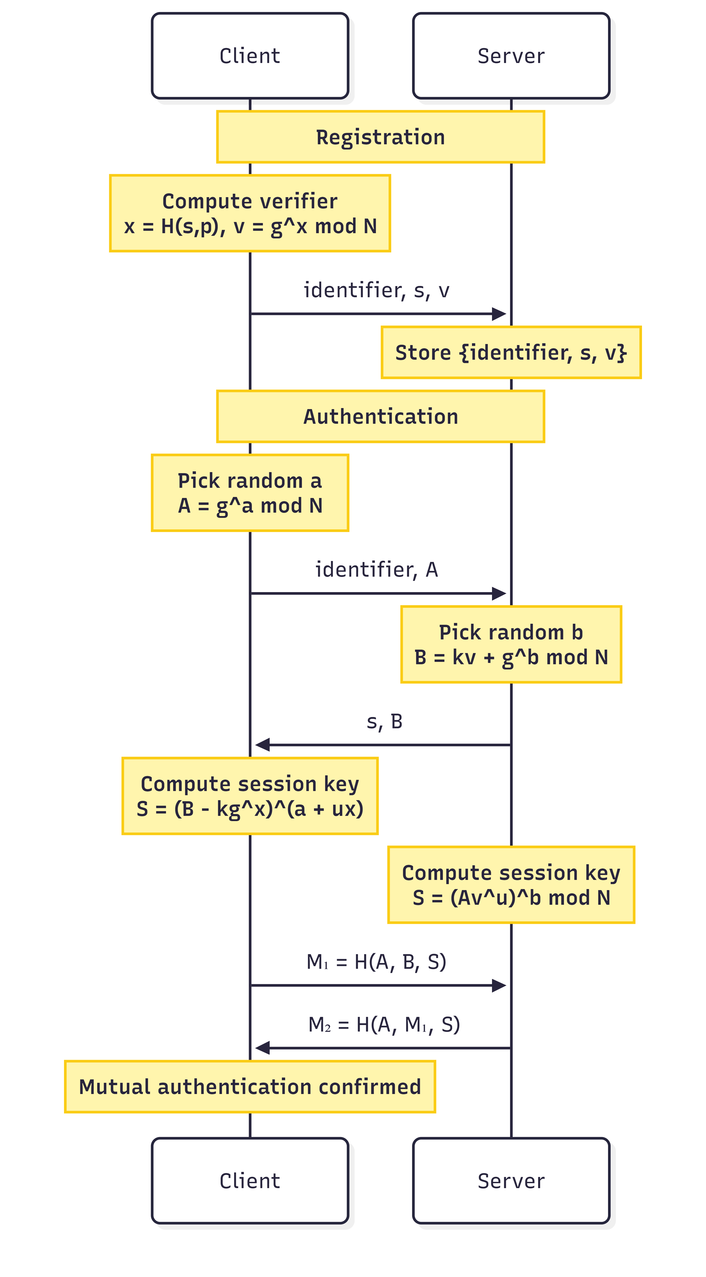
Figure 1 Sequence Diagram of the SRP-6a Protocol

Replay Attacks
A replay attack is a form of network-layer attack in which a valid authentication message previously captured by an adversary is retransmitted later with the intent of gaining unauthorized access [4]. Such attacks are particularly effective against systems that rely on static authentication credentials or reusable authentication tokens. If intercepted data remains valid across multiple sessions, an attacker may be able to authenticate successfully without knowing the user's password.
SRP-6a mitigates replay attacks by using fresh ephemeral values in every authentication session. At the beginning of each login attempt, the client generates a new random value a, while the server generates a new random value b. These values produce unique public parameters A and B, which in turn lead to a unique session key K for every authentication exchange.
Since the authentication proofs M₁ and M₂ are derived from session-specific parameters, messages captured from a previous session cannot be reused successfully in a future session. Even if an attacker records a complete and valid authentication exchange, replaying the captured messages will fail because the server generates a different ephemeral value for each new session, resulting in a different expected proof.
Although SRP-6a provides replay protection at the protocol level, transport-layer security mechanisms such as TLS remain important in practice. TLS protects protocol messages from passive observation and modification, providing an additional layer of defense against network-based attacks and complementing the security guarantees offered by SRP-6a.

Prepare Your Paper Before Styling
Before you begin to format your paper, first write and save the content as a separate text file. Keep your text and graphic files separate until after the text has been formatted and styled. Do not use hard tabs, and limit use of hard returns to only one return at the end of a paragraph. Do not add any kind of pagination anywhere in the paper. Do not number text heads-the template will do that for you.
Finally, complete content and organizational editing before formatting. Please take note of the following items when proofreading spelling and grammar:

Abbreviations and Acronyms
Define abbreviations and acronyms the first time they are used in the text, even after they have been defined in the abstract. Abbreviations such as IEEE, SI, MKS, CGS, sc, dc, and rms do not have to be defined. Do not use abbreviations in the title or heads unless they are unavoidable.

Units
- Use either SI (MKS) or CGS as primary units. (SI units are encouraged.) English units may be used as secondary units (in parentheses). An exception would be the use of English units as identifiers in trade, such as “3.5-inch disk drive.”
- Avoid combining SI and CGS units, such as current in amperes and magnetic field in oersteds. This often leads to confusion because equations do not balance dimensionally. If you must use mixed units, clearly state the units for each quantity that you use in an equation.
- Do not mix complete spellings and abbreviations of units: “Wb/m2” or “webers per square meter,” not “webers/m2.” Spell units when they appear in text: “...a few henries,” not “...a few H.”
Identify applicable sponsor/s here. If no sponsors, delete this text box (sponsors).
- Use a zero before decimal points: “0.25,” not “.25.” Use “cm3,” not “cc.” (bullet list)

Equations
The equations are an exception to the prescribed specifications of this template. You will need to determine whether or not your equation should be typed using either the Times New Roman or the Symbol font (please no other font). To create multileveled equations, it may be necessary to treat the equation as a graphic and insert it into the text after your paper is styled.
Number equations consecutively. Equation numbers, within parentheses, are to position flush right, as in (1), using a right tab stop. To make your equations more compact, you may use the solidus ( / ), the exp function, or appropriate exponents. Italicize Roman symbols for quantities and variables, but not Greek symbols. Use a long dash rather than a hyphen for a minus sign. Punctuate equations with commas or periods when they are part of a sentence, as in
a  b             
Note that the equation is centered using a center tab stop. Be sure that the symbols in your equation have been defined before or immediately following the equation. Use “(1),” not “Eq. (1)” or “equation (1),” except at the beginning of a sentence: “Equation (1) is ...”

Some Common Mistakes
- The word “data” is plural, not singular.
- The subscript for the permeability of vacuum μ₀, and other common scientific constants, is zero with subscript formatting, not a lowercase letter “o.”
- In American English, commas, semi-/colons, periods, question and exclamation marks are located within quotation marks only when a complete thought or name is cited, such as a title or full quotation. When quotation marks are used, instead of a bold or italic typeface, to highlight a word or phrase, punctuation should appear outside of the quotation marks. A parenthetical phrase or statement at the end of a sentence is punctuated outside of the closing parenthesis (like this). (A parenthetical sentence is punctuated within the parentheses.)
- A graph within a graph is an “inset,” not an “insert.” The word alternatively is preferred to the word “alternately” (unless you really mean something that alternates).
- Do not use the word “essentially” to mean “approximately” or “effectively.”
- In your paper title, if the words “that uses” can accurately replace the word using, capitalize the “u”; if not, keep using lower-cased.
- Be aware of the different meanings of the homophones “affect” and “effect,” “complement” and “compliment,” “discreet” and “discrete,” “principal” and “principle.”
- Do not confuse “imply” and “infer.”
- The prefix “non” is not a word; it should be joined to the word it modifies, usually without a hyphen.
- There is no period after the “et” in the Latin abbreviation “et al.”
- The abbreviation “i.e.” means “that is,” and the abbreviation “e.g.” means “for example.”
An excellent style manual for science writers is [7].

Using the Template
After the text edit has been completed, the paper is ready for the template. Duplicate the template file by using the Save As command, and use the naming convention prescribed by your conference for the name of your paper. In this newly created file, highlight all of the contents and import your prepared text file. You are now ready to style your paper; use the scroll down window on the left of the MS Word Formatting toolbar.

Authors and Affiliations
The template is designed so that author affiliations are not repeated each time for multiple authors of the same affiliation. Please keep your affiliations as succinct as possible (for example, do not differentiate among departments of the same organization). This template was designed for two affiliations.

For author/s of only one affiliation (Heading 3): To change the default, adjust the template as follows.

Selection (Heading 4): Highlight all author and affiliation lines.

Change number of columns: Select the Columns icon from the MS Word Standard toolbar and then select “1 Column” from the selection palette.

Deletion: Delete the author and affiliation lines for the second affiliation.

For author/s of more than two affiliations: To change the default, adjust the template as follows.

Selection: Highlight all author and affiliation lines.

Change number of columns: Select the “Columns” icon from the MS Word Standard toolbar and then select “1 Column” from the selection palette.

Highlight author and affiliation lines of affiliation 1 and copy this selection.

Formatting: Insert one hard return immediately after the last character of the last affiliation line. Then paste down the copy of affiliation 1. Repeat as necessary for each additional affiliation.

Reassign number of columns: Place your cursor to the right of the last character of the last affiliation line of an even numbered affiliation (e.g., if there are five affiliations, place your cursor at end of fourth affiliation). Drag the cursor up to highlight all of the above author and affiliation lines. Go to Column icon and select “2 Columns”. If you have an odd number of affiliations, the final affiliation will be centered on the page; all previous will be in two columns.

Identify the Headings
Headings, or heads, are organizational devices that guide the reader through your paper. There are two types: component heads and text heads.
Component heads identify the different components of your paper and are not topically subordinate to each other. Examples include ACKNOWLEDGMENTS and REFERENCES, and for these, the correct style to use is “Heading 5.” Use “figure caption” for your Figure captions, and “table head” for your table title. Run-in heads, such as “Abstract,” will require you to apply a style (in this case, italic) in addition to the style provided by the drop down menu to differentiate the head from the text.
Text heads organize the topics on a relational, hierarchical basis. For example, the paper title is the primary text head because all subsequent material relates and elaborates on this one topic. If there are two or more sub-topics, the next level head (uppercase Roman numerals) should be used and, conversely, if there are not at least two sub-topics, then no subheads should be introduced. Styles named “Heading 1,” “Heading 2,” “Heading 3,” and “Heading 4” are prescribed.

Figures and Tables

Positioning Figures and Tables: Place figures and tables at the top and bottom of columns. Avoid placing them in the middle of columns. Large figures and tables may span across both columns. Figure captions should be below the figures; table heads should appear above the tables. Insert figures and tables after they are cited in the text. Use the abbreviation “Fig. 1,” even at the beginning of a sentence.
- Table Styles
Table Head | Table Column Head
 | Table column subhead | Subhead | Subhead
copy | More table copyª
- Sample of a Table footnote. (Table footnote)

- Example of a figure caption. (figure caption)
Figure Labels: Use 8 point Times New Roman for Figure labels. Use words rather than symbols or abbreviations when writing Figure axis labels to avoid confusing the reader. As an example, write the quantity “Magnetization,” or “Magnetization, M,” not just “M.” If including units in the label, present them within parentheses. Do not label axes only with units. In the example, write “Magnetization (A/m)” or “Magnetization (A ( m(1),” not just “A/m.” Do not label axes with a ratio of quantities and units. For example, write “Temperature (K),” not “Temperature/K.”

Acknowledgment (Heading 5)
The preferred spelling of the word “acknowledgment” in America is without an “e” after the “g.” Avoid the stilted expression “one of us (R. B. G.) thanks ...”. Instead, try “R. B. G. thanks...”. Put sponsor acknowledgments in the unnumbered footnote on the first page.

References
The template will number citations consecutively within brackets [1]. The sentence punctuation follows the bracket [2]. Refer simply to the reference number, as in [3]—do not use “Ref. [3]” or “reference [3]” except at the beginning of a sentence: “Reference [3] was the first ...”
Number footnotes separately in superscripts. Place the actual footnote at the bottom of the column in which it was cited. Do not put footnotes in the reference list. Use letters for table footnotes.
Unless there are six authors or more give all authors’ names; do not use “et al.”. Papers that have not been published, even if they have been submitted for publication, should be cited as “unpublished” [4]. Papers that have been accepted for publication should be cited as “in press” [5]. Capitalize only the first word in a paper title, except for proper nouns and element symbols.
For papers published in translation journals, please give the English citation first, followed by the original foreign-language citation [6].
- M. Bellare and P. Rogaway, "Entity authentication and key distribution," in Proc. Advances in Cryptology (CRYPTO), Santa Barbara, CA, USA, Aug. 1993, pp. 232–249.
- T. Wu, "SRP-6: Improvements and Refinements to the Secure Remote Password Protocol," 2002.
- D. Taylor, T. Wu, N. Mavrogiannopoulos, and T. Perrin, "Using the Secure Remote Password (SRP) protocol for TLS authentication," IETF, Fremont, CA, USA, RFC 5054, Nov. 2007. [Online]. Available: https://www.rfc-editor.org/rfc/rfc5054
- W. Stallings, Cryptography and Network Security: Principles and Practice, 8th ed. Hoboken, NJ, USA: Pearson, 2017, pp. 63–65.

PERNYATAAN
Dengan ini saya menyatakan bahwa makalah yang saya tulis ini adalah tulisan saya sendiri, bukan saduran, atau terjemahan dari makalah orang lain, dan bukan plagiasi.

Bandung, 18 Juni 2026
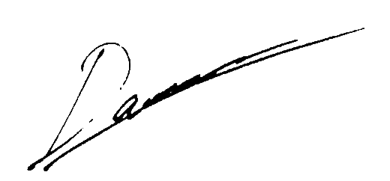
Darren Mansyl
18223001

